IMAP vs. POP3 | Difference between IMAP and POP3

**POP3 and IMAP** are the popular email protocols that are used to access emails from a third-party email client or software. These two are the commonly used Email Protocols on the internet. Both these protocols help to connect to the mail server with the email client through which you have set up your email address. We can select any one of them to set up our email address. Similar to Simple Mail Transfer Protocol (SMTP), POP3 and IMAP also have specific functions and working principles. Let's discuss the POP3 and IMAP in detail, along with their differences.

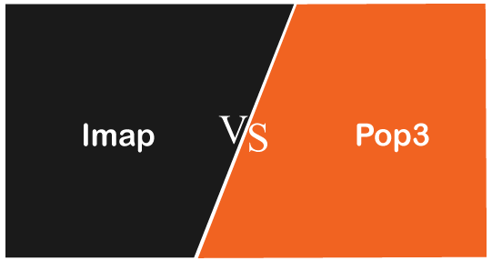

What is IMAP?

[IMAP](https://www.javatpoint.com/imap-protocol) is abbreviated as **Internet Message Access Protocol**.*IMAP is an internet protocol that works on managing and retrieving emails on the remote server from a local client. It*also works as MAA **or Message Accessing Agent**. Since IMAP deals with the retrieval of messages so we can't send emails using IMAP protocol on the internet. The IMAP protocol is supported by all email clients and web servers.

**The working of IMAP is shown in below image:**

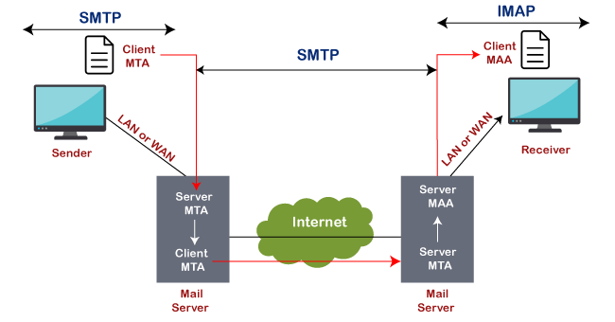

When to use IMAP?

If you are accessing your email from different devices like mobile, laptop and workstation desktop, etc., then it always better to use the IMAP protocol.

Features of IMAP

There are some features of IMAP, which are as follows:

* Emails are stored on the server instead of an email client.
* Sent messages are also stored on the server-side in the sent folder, which allows us to check the sent email from anywhere.
* You can synchronize the messages and access youremail from multiple devices.
* It is more complex and flexible.
* It helps to download email data from AOL to your device or software.
* We will not lose our emails even if our device is destroyed or stolen.
* The server also saves the status of the emails, such as read, unread, or replied. It helps to check the status of an email from any computer or device.
* When we start downloading emails using IMAP, it firstly shows the header (Sender, date, email subject); at that instant, we can decide whether to download the email or not.

What is POP3?

POP3 is abbreviated as **Post Office Protocol**, and the number three stands for "version 3," which is the latest version and the most widely used email protocol on the internet. Similar to IMAP protocol, it is another protocol for receiving emails from remote servers. It also acts as a message accessing agent to retrieve the message from the mail server to the receiver's system. It helps to protect emails from spam and viruses on the internet.

POP3 works on two modes: **Delete mode** and **Keep mode.**

It works on **Delete mode** when a user is accessing an email service from a permanent device. In this, once the mails are downloaded or retrieved from the mailbox, mails are deleted from the mailbox permanently.

It operates on **Keep mode** when the user is not accessing mails from the primary device. In this, it keeps the mails after retrieval also for later retrieval.

When to Use POP3?

Use POP3 for the following cases:

* We should use POP3 if we want to access mails using a single device
* If the number of emails is high.
* If we want to access the mails offline.

Features of POP3

* In POP3, all the emails are downloaded to the local computer, and once all the emails are downloaded, they are deleted from the server.
* Downloaded emails can be accessed offline also.
* Emails are not synchronized between different devices, which means if we set up our email using our mobile phone with POP3, those emails will be downloaded completely on your mobile phone, and cant be accessed from other devices.

Difference table between IMAP and POP3

|  |  |  |
| --- | --- | --- |
| **Feature** | **IMAP** | **POP3** |
| Stands for | IMAP stands for Internet Message Access Protocol. | It stands for Post Office Protocol3. |
| Used for | IMAP is an advanced protocol that allows a user to check all the folders on the mail server and is used to retrieve the mails. | POP is a simple protocol compared to IMAP and used only for downloading the messages from our inbox to the local computer. |
| Port number | It listens on port number 143, and IMAPDS(IMAP with SSL) Listens on port 993. | It listens on port number 110, and POP3DS(POP3 with SSL) listens on port 995. |
| Accessibility | Using IMAP, the messages can be accessed using different devices. | Using POP3, mail can only be accessed using a single device at a time. |
| Readability | We can partially read the message before finishing the download. | We can only read the message once it is downloaded. |
| Change | In IMAP, a mail can be updated using email software or a web interface. | In POP3, mail can be updated using the local email software. |
| Update | IMAP allows the user to create, delete, or update the mailboxes on the mail server and also allows to create a hierarchy of mailboxes in the folder. | POP3 does not allow the user to create, delete, or update the mailboxes on the mail server. |
| Mail organization | It allows the user to organize the mails on the server. | It does not allow to organize the mails on the server. |
| Download | In IMAP, the message header is previewed before downloading a message. | Using POP3, all the messages can be downloaded at once. |
| Email storage | Emails are stored on a single device once they are downloaded and removed from the server. | Emails are stored on the server and synced & can be accessed using multiple devices. |

Conclusion

As per the above discussion, we can conclude that IMAP is more powerful, and it is best to use it if we want to access our emails using multiple devices, for example, using smartphones and computers. On the other hand, POP3 is suitable if we access mails using one device only, with a large number of emails, and want to access those emails offline.